**Format to report your ADVANCED JAVA PROGRAMMING PROJECTS**

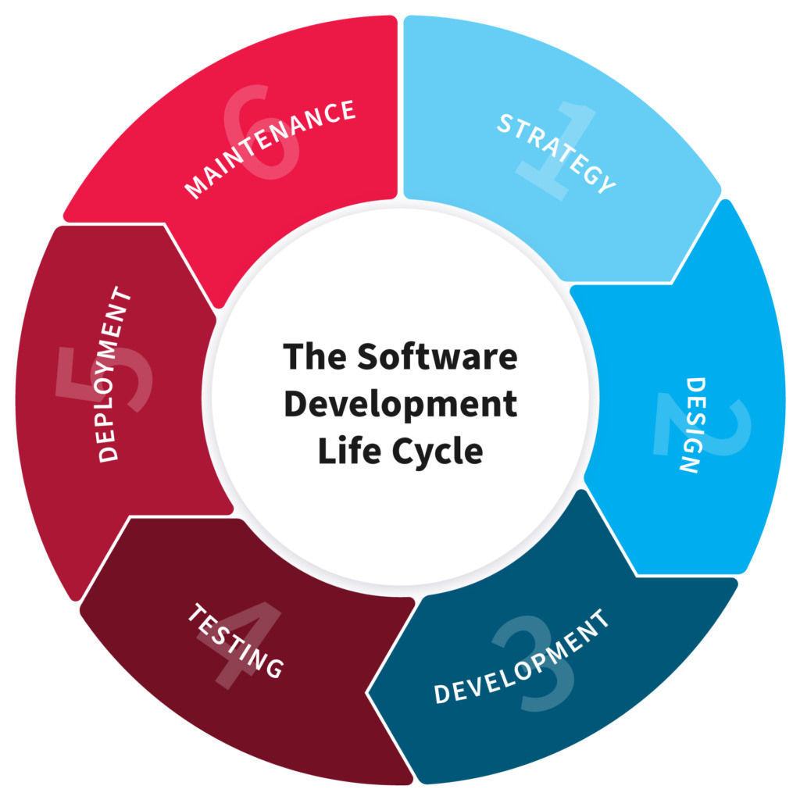

**NAME: UMURERWA MIREILLE**

**REG NO: 220013685**

**CLASS NO: Group 2**

**PROJECT NAME: Todo-App**

1.PLANNING

“In this Section, Students, have to define the system (your projects) goals and objectives and the problems the future system needs to solve.”

What is Todo-App?

Is an application specially built to keep tasks that needs to be done? This application will be like task keeper where the user would be able to enter the tasks they need to do. Once you are done with their tasks they can also remove them from the list.

Goals and Objectives of Todo-App are being to offer a way to increase

Productivity, stopping people from forgetting things, use time wisely, helps prioritise tasks, manage tasks effectively and improve time management as well as workflow.

the problems the future system needs to solve are the following:

* Forgetting to do things
* Waste of time
* Mismanage of tasks
* Not prioritizing your tasks
* Low productivity

2. Design

“In this Section, students’ needs to elaborate how the system will work, focusing on software design and how it works with the technical and functional requirements of the system. Depicts also how your team defined how users will interact with the software.”

Through this stage we refer to the overall look and feel, as well as the layout and functionality, of our to-do app. This includes the visual elements such as

Colors,

Typography,

and icons,

as well as the placement of buttons and other interactive elements. The design is user-friendly, visually appealing, and easy to navigate.

In terms of functionality, our app grant users to add, edit, and delete to-do items, as well as give options to set reminders, and prioritize tasks. The app should also provide a way for users to view their to-do items, such as through a list or calendar view.

3. DEVELOPMENT

“In this Section, Students need to elaborate how they build the entire system (Front end- back end technologies), chosen libraries, platforms, storage and databases, adopted technologies, etc...”

* We developed the system backend and frontend parts using java programming language by JSP and Servlet
* For frontend parts, we used JSP Framework to create forms, buttons, labels as well as a user interface as a whole.
* We applied MySQL as a database management system to keep backend data.
* We design interactions between user interface components such as forms and buttons using Servlet java programming language syntaxes.
* We applied com.mysql.jdbc_5.1.5.jar as a library handling MYSQL connection with the system.

4. TESTING

“In this Section, Students to show the way this stage was conducted. Ensuring that everything works as expected. Which defects and bugs you found, and how did you fixed them to ensure that the product meets the original specifications.”

We tested our application with

* Unit testing: This involves writing individual test cases for specific methods or classes in the application.
* Integration testing: This involves testing the interactions between different components of the application, such as between the front end and back end.
* Functional testing: This involves testing the application as a whole, to ensure that it works as intended and meets the requirements.
* Performance testing: This involves testing the application's performance, such as its response time and memory usage, under different loads and conditions.
* Manual testing: This involves manually testing the application by going through various scenarios and user flows and checking for any bugs or issues.

5. DEPLOYMENT

* Installing MYSQL as a database management system.
* Download and configure com.mysql.jdbc_5.1.5.jar as a library handling MYSQL connection.
* Use portable storage devices to transfer projects from the development computer to any library’s librarian computer.
* Run the project file and start using the system

6. MAINTENANCE

In our app maintenance we include tasks such as

* Monitoring and addressing any issues or bugs reported by users
* Continuously improving and updating the app's user interface and functionality
* Adding new features or integrations as needed
* Backing up user data to ensure data is not lost in case of issue
* Regularly testing the app to ensure it is functioning correctly
* Addressing any compliance and regulatory issues that may arise.